Fall 2018 Conference Schedule
Oct 4-5, 2018 - Clemson University
The Madren Conference Center – 230 Madren Center Road, Clemson, SC 29631 – 864-656-7155
Free parking at the Madren Center; no code or pass is needed
Thursday, Oct 4:
3:00: Walking tour of South Carolina Botanical Garden
We will depart from the Madren Center at 3:00. Tiger Transit will take us to the Garden and the tour will last about an hour. After the tour, we will return to the Madren Center to Joe’s Bar for happy hour. Light snacks will be provided.
The tour is a general overview of the Garden's history and development. We visit the more established area of the Garden, the Hosta Garden, Duck Pond and part of the Natural Heritage Trail. Since we are in the Piedmont, the terrain is not flat but undulating. Good shoes are a good idea!
Dinner on your own:
Restaurant Recommendations:
1. The Esso Club – Sports Bar -- 129 Old Greenville Hwy #1 (1.4 miles from the Madren Center)
2. Mellow Mushroom – Pizza -- 1007 Tiger Blvd (4 miles from the Madren Center)
3. Sole on the Green – Upscale Casual – (Located at the Madren Center)
4. Tiger Town Tavern – Sports Bar -- 368 College Ave (2.1 miles from the Madren Center)
5. Brioso – Italian -- 360 College Ave (2 miles from the Madren Center)
6. BGR: The Burger Joint – Burgers -- 378 College Ave (2.1 miles from the Madren Center)
7. Pixie and Bill’s – Upscale Dining -- 1058 Tiger Blvd (3.4 miles from the Madren Center)
8. Blue Heron – Upscale Dining -- 405 College Ave (2.4 miles from the Madren Center)
9. Yolk Asian Kitchen -- Asian – 906 Tiger Blvd (3.8 miles from the Madren Center)
10. Your Pie – Pizza – 111 Earle St (2.3 miles from the Madren Center)
Friday, Oct 5: Madren Center – BellSouth Auditorium
8:30 – 9:30: Registration, Light Breakfast, and Networking
9:30 – 9:45: Welcome Remarks
9:45 – 10:45: SESSION 1 – Jennifer Vincent, Prospect Development Manager, UNCW
X Marks the Spot: Geographic Prospecting using Microsoft Excel
A tour of how to use Microsoft Excel to quickly create 3D maps of development portfolios, prospects, events, and/or any other data with an address. Learn how to overlay portfolios with new prospects to identify prospect hot-spots and help maximize travel plans. This session will walk you through creating a 3D map and give ideas of how to use the data to spot donor trends and visualize your fundraising potential. You will leave the session with a quick and easy project to show off when you get back to the office.
10:45 – 11:15: SESSION 2 – Mike Sanders, Target Analytics
Best Practices for Data Cleanliness
(full description forthcoming)
11:15 – 11:30: Break
11:30 – 12:30: SESSION 3 – Missy Garner, Executive Director of Prospect Research and Prospect Management, University of Georgia & Rick Loveday, Prospect Research Analyst, Clemson University
How to Develop an Analytics Project: Building a Model Score
This session will cover how Clemson’s Prospect Research Team developed a philanthropic model score and is based on their blog series. This project began as a way to identify key philanthropic characteristics in our constituent base. They wanted to know what types of attributes drive people to be philanthropic. This brought them to a specific group of their constituents who had donated at the principal gift level. They wanted to see if this subset exhibited any shared characteristics beyond the standard information contained in their CRM such as event participation, board membership, demographic data, etc. No matter how strong the data is, it only provides information about a constituents’ relationship with your institution. Our data won’t tell you how your constituents are interacting with other organizations or institutions; this inspired Clemson to look for outside resources that would fill this gap in their data.
12:30 – 1:30: Lunch and Networking
1:15 – 1:30: Chapter Updates and Awards
1:30 – 2:15: SESSION 4 – Krystal Wilson, Associate Director of Prospect Management & Research, Appalachian State University
Timeout: Determining a Strategy with Athletics
It is no secret that there seems to be a gap between Advancement Services (Prospect Development included) and Athletics. However, it is not a blame game. We all need to take a timeout to define the gap and examine it, in order to build a bridge and move forward together. This presentation is a discussion on how to build partnerships for success with athletics' fundraisers and can provide some helpful tools to take back to your shop.
2:15 – 2:30: Break
2:30 – 3:30: SESSION 5 – Business Card Blitz
Networking opportunity that will combine opportunities of meeting colleagues and discussing topics relevant to prospect development.
3:30 Closing Remarks

Jennifer Vincent is the Manager of Prospect Development at UNC Wilmington. She joined the Prospect Development department at UNCW in 2008 and served in several positions before becoming the head of Prospect Development in 2016. Her current position focuses on overseeing the assignment and management of Major Gift prospects and portfolios. She works directly with the Major Gifts team to strategize and maximize prospect potential and ensure proper flow through the pipeline. Prior to her career in Prospect Development, she was the office manager at a neuropsychological testing facility. She graduated magna cum laude with her B.A. in Psychology and Criminal Justice from UNC Wilmington and holds a certificate in Nonprofit Donor Analytics from Baruch College - CUNY. She has been a member of Apra Carolinas since 2015 and currently serves as the Chair of their Membership Committee.
Mike Sanders is the Target Analytics Account Manager for universities and colleges in the Carolinas. Based in Charleston SC he has been with Blackbaud since 1996 and in his current role since 2006. During his time at Blackbaud he has worked in a variety of roles including customer support, training, consulting and sales. He also spent four years working in the Blackbaud Europe office in Glasgow, Scotland. He is married to Andrea and has an 18 year old daughter Caroline and 14 year old son David.

Rick Loveday is a Prospect Research Analyst at Clemson University. He joined the Prospect Research team in 2016. He supports the College of Business; the College of Art, Architecture, and Humanities; the College of Behavioral, Social, and Health Sciences; the College of Education; Student Affairs; Diversity and Inclusion; and the Associate Vice President for Development. In addition to his prospect research duties, Rick also handles report development, analytics, and all things Tableau. Prior to joining Clemson, he ran a film production company, wrote and published two novels, and worked in the tech support and paralegal fields. He graduated from Clemson University with a degree in English. He later earned an A.A.S. in Paralegal Studies from Greenville Technical College. Rick is currently completing his certificate in Public Administration and will be pursuing a Masters in Data Science and Analytics.

Krystal Wilson is trained as a leader in Higher Education, and has an 11 year background in advancement services, project management, research, strategic planning, and team building. Currently, Krystal is the Associate Director of Prospect Management and Research at Appalachian State University. She earned her doctorate in
educational leadership and policy analysis from East Tennessee State University in 2015. She holds an Education Specialist degree and a Master of Arts degree in higher education, and a Bachelor of Science degree in public relations from Appalachian State University. Through Appalachian State University's professional development program, she completed the Supervisor Development Institute in 2017, and the Agents of Change program in 2018.
Her current volunteer efforts include Boone Service League, Meals on Wheels, and the Back 2 School Festival.

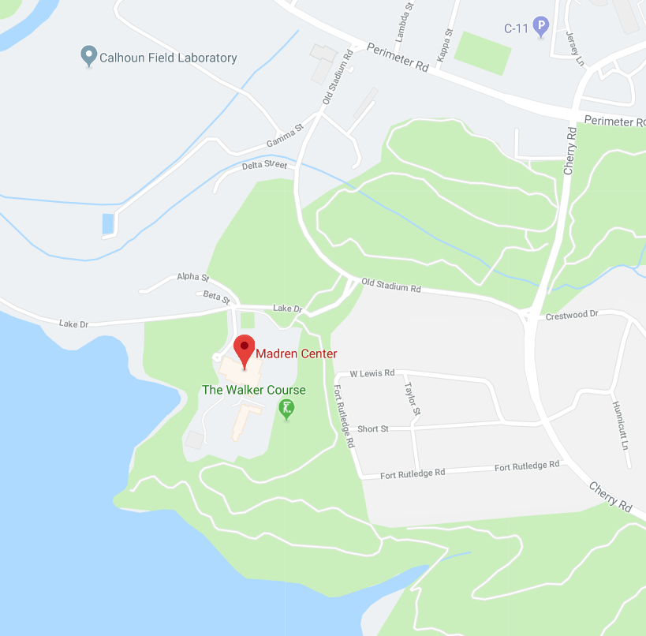
230 Madren Center Road
Clemson, SC 29631
864-656-7155

